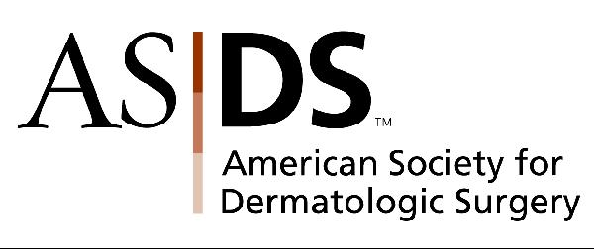

ASDS e-Alert: ASDS Supports Botox Labeling
January 25, 2008

Dear ASDS Colleague,

This week, news reports were aired on such media outlets as Good Morning America and CNN questioning the safety of Botox® after the group Public Citizen called for stricter labeling and black box warnings on the use of the drug. This consumer watchdog group cited reports to the US Food and Drug Administration's Adverse Events Reporting System (AERS) database of 16 deaths that had occurred in persons to whom the neurotoxin had been administered.

According to a news release issued by Allergan on January 25, Dr. Sef Kurstjens, Allergan's Chief Medical Officer, responded to allegations that in 2003 a death had occurred in a person who had been injected with Botox® for cosmetic use. A medical review of this actual case showed that the patient died from complications associated with staphylococcus pneumonia, not from the Botox® injection that the patient had received seven weeks earlier. This conclusion is consistent with the treating physician's assessment.

The Society believes the current labeling for Botox® is appropriate and does not believe further warnings are necessary. Members are aware of the risks associated with Botox® and while it is known that Botox® may have adverse effects, these effects are already comprehensively communicated in the drug labeling. In addition, none of the adverse effects has ever included a death to our knowledge.

To help you answer questions from the media, your patients and colleagues, ASDS has developed the following talking points:
- Botox® Cosmetic has been FDA-approved and in continuous use since 1989 with rare reports of adverse effects, most of which were minimal and transitory.
- In 2005, almost 575,000 Botox® injections were performed by ASDS members with no reports of deaths or other major complications.
- The patient whose death was linked to Botox® by Public Citizen did not have any symptoms of an adverse reaction after injection. Her death was from infectious pneumonia, seven weeks after the injection, and was not causal.
- Dermatologic surgeons are aware of the potential of side effects of Botox® and thoroughly inform patients of them when administering the drug.
- The ASDS and dermatologic surgeons are not aware of any deaths that have occurred as a direct result of the use of Botox® throughout the history of the product's cosmetic use.
- Many of the people who receive Botox® for non-cosmetic reasons have underlying health issues and co-morbidities that may also contribute to the adverse effects that were reported.
- The AERS database is intended to encourage physicians to report any drug reaction. A report of an event does not by itself mean that the drug caused the event; just that the event occurred after the drug was administered.
- In its petition, Pubic Citizen cites adverse effects culled from the AERS database over a ten year period, but explicitly states that "causality cannot be proved" with respect to these adverse event reports.
If you are giving a presentation at the upcoming AAD meeting in San Antonio on Botox®, please make sure that you are prepared to address questions on this issue from the media and your colleagues.

Please contact Lisa Doty, Marketing and Communications Manager, at ldoty@asds.net or 847-956-9133 if you have any questions or need additional information.

Sincerely,

Darrell S. Rigel, MD
President

